
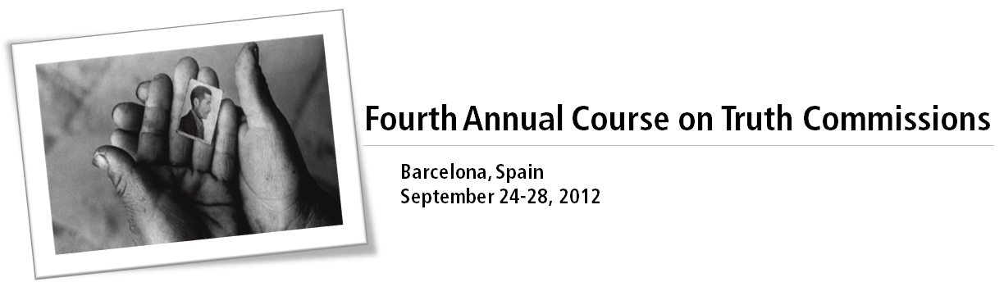

Application FORM

Applicant Information
Full Name:
Date of birth (mm/dd/yyyy): |  | Country of Residence: |  | Sex: Male Female
Mailing address:
City: |  | State: |  | Postal Code:
Daytime Phone: |  | Fax: |  | E-mail:
Proficiency in English (Course is taught in English): Fair Good Fluent

Employment & BACKGROUND Information
Current employer:
Position:
Other institutional affiliations (if relevant):
Current title:
Areas of expertise (please list all that apply and indicate your experience level):

RECOMMENDER INFORMATION & RECOMMENDATION LETTER
Name:
Title and Institution:
Address:
City: |  | State: |  | Postal Code:
Phone: |  | Fax: |  | E-mail:
*Please note: We receive many applications. To facilitate processing, we prefer receiving all application documents including recommendation letter as attachments in a single email sent from the applicant to Kelen Meregali at tmcourses@ictj.org. If your recommender would prefer to send the letter directly he/she may do so, however, we ask that you please indicate this clearly in your application email to us.

curriculum vitae
Please attach an up-to-date CV with the following information: (A) employment history; (B) education; (C) publications; (D) other practical experience.

cover letter
Please attach a 1-page cover letter explaining the following: (A) Why are you interested in being a part of the ICTJ Intensive Course on Truth-Seeking? (B) Why is this course relevant to your work? How do you expect to apply what you learn?

check list OF ATTACHMENTS
Application form | CV |  | Letter of recommendation |  | Cover letter

importante notice
Please submit by complete applications in a single email to Kelen Meregali at tmcourses@ictj.org. To facilitate processing, please use the email subject line “ICTJ Intensive Course Application – [Your Name]”. You will be notified upon receipt of the full application.
APPLICATION DEADLINE IS JUNE 25TH, 2012.
Photo: A woman shows the photo ID of a relative who disappeared in Ayacucho, Peru (1984). Photo credit: Vera Lentz.

